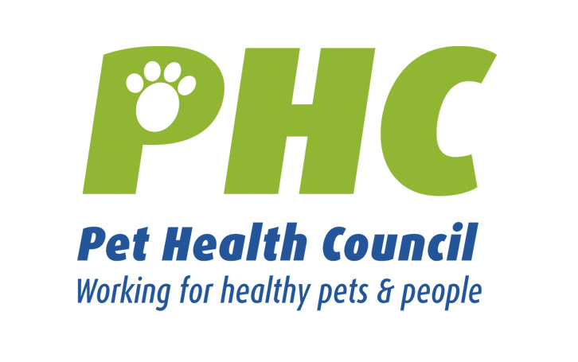PET HEALTH MATTERS
www.pethealthcouncil.co.uk

TWELVE DAYS OF CHRISTMAS AND NEW YEAR’S RESOLUTIONS

The count down to Christmas has begun and the Pet Health Council has developed 12 great tips so you and your pet can make the festive season a happy one!

On the twelfth day of Christmas, the PHC recommends…when planning a Christmas break, make sure you book a kennel or cattery well in advance as it’s a busy time of year for them. It’s a good idea when packing your pets bags to include a favourite toy or blanket so they don’t get home sick.

On the eleventh day of Christmas, the PHC recommends…thinking of your pets when you decorate the Christmas tree. Sparkly tinsel and colourful decorations look very appealing to play with but could be dangerous if swallowed.

On the tenth day of Christmas, the PHC recommends… checking if your dog is taking much longer to get up as the cold weather sets in. ‘Old age’ is not a disease as such, but brings with it painful conditions like arthritis. Your vet will be able to advise you on suitable medication that will put the spring back into old bones.

On the ninth day of Christmas, the PHC recommends… making sure you rinse your dog’s paws with warm water after a walk, as when the roads have been gritted, the salt and grit can irritate the tender skin between the toes.

On the eighth day of Christmas, the PHC recommends…not leaving chocolate lying around at Christmas as it is toxic for dogs. Only feed them specially formulated ‘chocolate’ treats. You should also remember when serving Christmas pudding that grapes and raisins can damage dogs’ kidneys, so you’d better eat it yourself.

On the seventh day of Christmas, the PHC recommends…tidying away children’s toys, especially if they have small pieces which could be swallowed and get lodged in your pet’s throat.

On the sixth day of Christmas, the PHC recommends…always supervising young children when playing with animals.

On the fifth of Christmas, the PHC recommends…keeping household plants out of reach from pets as some may be toxic. These include the Christmas favourites such as poinsettias, mistletoe, spider plants and ferns.

On the fourth day of Christmas, the PHC recommends…securing your Christmas tree properly to ensure that it can’t be pulled over by a playful pet. Also keep tree light wires out of your pet’s reach to avoid them being chewed.

On the third day of Christmas, the PHC recommends…pamper your pet a little, give them a special brush and teeth clean ready for the family arriving. How about a special pet treat or snack under the tree?

On the second day of Christmas, the PHC recommends… ensuring your leftover chicken or turkey is put in a safe place where your dog or cat can’t reach it. Your pet can easily choke on chicken and turkey bones.

And on Christmas day, the PHC recommends…walking your dog! Pets are used to their daily routines and you’ll both feel better for a bit of exercise after tucking into your lunch.

Remember the Christmas season is a time to relax and
have fun with your family and pets!

NEW YEAR RESOLUTIONS
When thinking about your own New Year’s resolutions, why not include some for your pet? Here are some ideas from the Pet Health Council:

- If your pet is looking podgy, don’t be tempted to put your pet on a crash diet. It’s best to consult your vet if you are considering a weight loss programme for your pet. They will probably prescribe a low calorie prepared diet – tailored especially for your pet and it’s individual condition.

- Exercise plays a very important role in weight reduction, and also improves general health. In the New Year, dog walking will not only help your pet but will help improve your fitness too. Research shows that walking a dog helps reduce your stress as well as keeping you fit.

- Start a home dental healthcare routine for your pet. Removing plaque regularly from your pet’s teeth should be part of your pet care routine. Ask your vet about the procedure for brushing your pet’s teeth. Pet owners may also feed specially formulated foods and treats that help reduce the accumulation of plaque and tartar from teeth.

