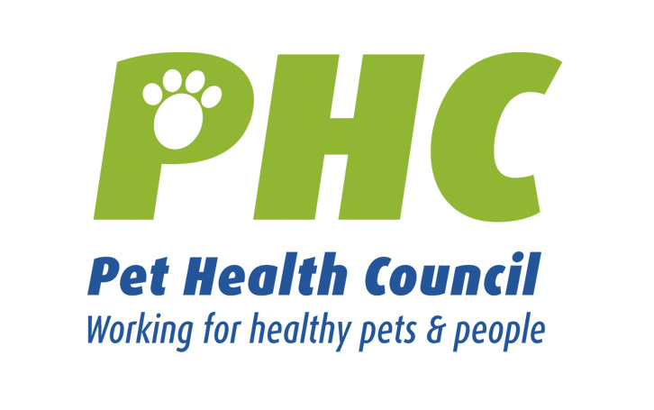PET HEALTH MATTERS
www.pethealthcouncil.co.uk

Pet safety and security
Our pets are much loved members of the family and keeping them happy and safe is an essential part of our duty of care to them. Unfortunately, today’s world can be a hazardous place for pets. In 2005, the Kennel Club alone reunited 70,000 lost or stolen dogs with their owners. With this in mind, the Pet Health Council has put together some advice to help keep your pet safe and out of harm’s way.
1. Identifying your Pet
Dogs are required by law to wear an identity tag carrying a contact phone number and address. Don’t put the dog’s name or any other personal details on the tag. If you are concerned about security you can put the number of any pet tracking company rather than your own details on the tag. If your dog gets lost, this tag will help others to identify you as the owner and to make sure that your dog is reunited with you.
Cats are not required by law to wear a collar. However, some form of identification is advisable. Since there is a risk that a collar may get caught up, for instance on a branch or on a fence, a special breakaway collar, designed to snap open quickly, is advised. Such a collar carrying essential owner information means that lost cats are more likely to be returned to their owners if lost and receive prompt veterinary attention if found injured by a stranger.
The most popular way of permanently identifying your pet is by micro-chipping. This is not a legal requirement, but it is the most reliable way to identify and trace lost or stolen pets as, unlike a collar, the implanted microchip cannot be removed. A chip about the size of a grain of rice is quickly and easily injected under the skin. Implantation is no more upsetting to the animal than a routine vaccination injection. It can be carried out by vets and other authorised personnel such as welfare organisations. Each microchip contains a unique code, which is held alongside the owner’s contact details by a centralised information centre. Veterinary practices, the police and pet rescue organisations have special hand-held scanners that can detect and read the unique identity on the microchip. It takes only a short phone call to match this data to the owner’s details so that the animal can be reunited with its owner without delay. It is important to ensure that you keep your contact details updated on the central database.
It is also a good idea to keep clear, up-to-date photos of your pet and to prepare a detailed written description just incase she ever goes missing. Look at her carefully and write down her coat type and colour, its pattern, colour of eyes and any distinguishing marks.
2. Out and About with your Dog
Dogs are much safer in all respects when they are on a lead. However, clearly dogs need the opportunity, when safe to do so, to run around, look, sniff and meet other dogs. Train your dog to stay within view when off the lead and to be reliably responsive to recall, whether that be by voice or whistle. If you are concerned about your pet’s recall, use an extending lead to allow him freedom whilst keeping him near to you. You may also want to consider enrolling your dog in a training class to teach him to come back when he is called.
It is tempting to leave your dog tied up outside a shop whilst you pop inside, however, it is important to remember how vulnerable your pet is whilst you are not with it. Dogs are frequently snatched at this time. Equally dogs left with inexperienced handlers are very vulnerable to opportunistic thieves.
Varying your walking routes regularly is exciting and fun both for you and your dog and it is also a good safety tip. Having a regular, predictable pattern may make your dog more of a target for thieves.
3. Beyond the Cat Flap
Cats often get themselves into trouble when they venture outside the home. Finding a way to get your cat to come indoors is a really useful tip for owners, for example by associating feeding with a particular sound, such as a bell, you can train your cat to come home to this sound. If you can keep your cat indoors overnight it will be safer and will help protect it from foxes, other cats, road traffic and a whole range of other dangers. Do not let a new cat venture outside for approximately four weeks, as it needs to establish where ‘home’ is by getting close attention from you, the owner, by being fed regularly and establishing a cosy sleeping area. Unless your garden is completely secure try to keep kittens indoors – until they are neutered if possible. Young kittens are very curious, but have little appreciation of danger.
4. Keeping Secure at Home
It is also worth taking some basic security measures at home to help keep your pet safe. Keep garden gates with access to the road closed and locked. Keep dogs in the back garden rather than the front so they are out of the way of prying eyes. Make sure fences are tall and strong enough to keep dogs in and unwanted visitors out.
Keep external doors closed and depending on the size, athleticism and curiosity of your pet, some owners may also want to keep their lower windows shut, to stop dogs and cats wandering off or thieves easily getting in.
The use of a house alarm system is a good deterrent to the opportunistic thief.
5. Taking out Insurance
For most people our pets are priceless, but they are also a big financial investment and pedigree animals are highly valuable. Pet owners may want to consider a pet insurance plan, which covers pets for theft or loss as well as reimbursing lost and found advertising costs in addition to the other big advantages of paying for veterinary fees and against third party damages.
6. If your pet does become lost or stolen
Cats tend to go on sojourns of varying length, and it is difficult to know if they are missing or just on an extended adventure. So check indoors carefully first to make sure they aren’t just sleeping in an unusual place. Then search outdoors. Most of the time cats will return by the evening, if your cat has not returned by morning, and this is really out of character for your pet, you should widen the search. You can inform local veterinary practices, animal welfare organisations and your local animal warden.
If your dog goes missing he should be reported missing to all of these agencies on the day that he goes missing.
Flyers with a photo or drawing of your pet highlighting identifying features can be circulated to local shops, veterinary surgeries and animal shelters. These should also detail where and when last sighted. Include a telephone number that will be manned 24 hours a day. Enlist the help of friends and neighbours. Other pet owners are usually very willing to keep a lookout for you. If you are out searching make sure someone is at your home in case the phone rings with information, or your pet comes home.
Visit animal shelters with photos of your pet and speak to the staff – and then keep in touch with them. Be aware that your pet may have a very changed appearance when found – may be matted, dirty, lost a collar and have lost weight – so finders may not link your photo or description with a found animal. Cats may be admitted to a shelter many months after they go missing as they can be fairly successful living on the streets.
In addition, local newspapers run lost and found adverts; some radio stations have these also; and there are Internet sites dedicated to finding missing pets.
Emotional support is available from the Pet Bereavement Support Service (PBSS) who can offer a listening ear to those whose pets have gone missing. PBSS was developed to support people through all types of pet loss situations. Contact PBSS by phone on 0800 09 66606 or email pbss@bluecross.org.uk
Thankfully the vast majority of owners are reunited with their pets.
When you find your pet remember to inform all agencies that were alerted and remove all flyers and lost notices – otherwise the lost and found system gets so clogged that other pets and owners may have great difficulty being reunited.
- ends -

Notes to Editors:
About the Pet Health Council
Established in 1979, the Pet Health Council promotes, informs and advises on the health and welfare of pet animals in the interests of both pets and people.
In addition to offering advice regarding the latest pet issues, the PHC promotes responsible pet ownership and the health benefits of pet interaction. www.pethealthcouncil.co.uk is a comprehensive source of information for consumers with a more detailed section for human health and veterinary professionals.

The PHC pools the expertise of its medical and veterinary advisors: Association of Pet Behaviour Counsellors, British Small Animal Veterinary Association, British Veterinary Association, National Office of Animal Health, National Pharmacy Association, Pet Food Manufacturers’ Association, Society for Companion Animal Studies, Royal College of Nursing Complementary Therapies Forum and Royal Pharmaceutical Society of Great Britain.

Pet Health Council
www.pethealthcouncil.co.uk
1 Bedford Avenue
London WC1B 3AU
t: 020 7255 5408 f : 020 7255 5454 e : phc@uk.grayling.com

